**Open file Using Command Prompt**

This document will explain how to Run CMD script.

In this zap automation open the file using command prompt.

**Step 1**: Double click on **“open File using command through. Zappy”.**

**Step 2:** Run Zappy Task window will popup, Click on **OK.**

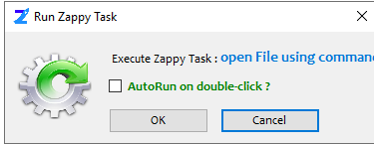

**Step 4:**  Select the file which you want to open, then click on open.

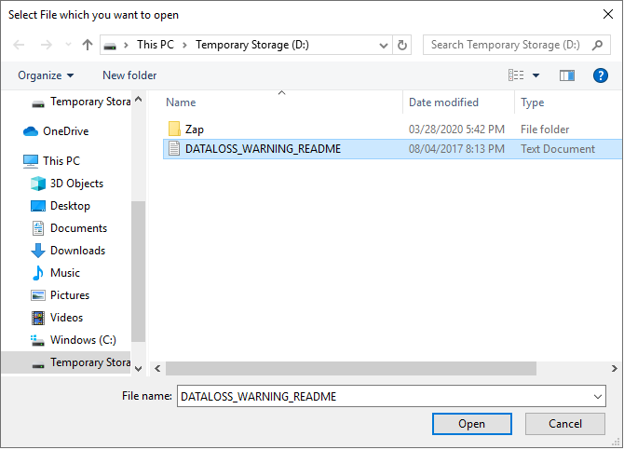

Will see the selected file is open.

**In this way we can use this automation to Open any file.**